WSS Help File

Table of Contents

Chapter I 3
1. Login Screen 3
Purpose: 3
Chapter II 4
1. UDC and UDC Type 4
Purpose: 4
A) Adding Or Changing a User defined Code Type 4
B) To Edit UDC Type and UDC 7
Chapter III 8
1. What is Template 8
Purpose: 8
2. How to Create a Template 8
A) Template Detail- 8
B) Call Detail- 9
c) Task Detail- 10
Chapter IV 12
1. Address Book 12
Purpose: 12
A) How to create new User/Company Address Book 13
i) Contact Info 19
ii) Additional Address Info 19
iii) Category Info 20
iV) Company Info 20
V) Personal Info 20
Vi) Skill Set Info 21
Chapter V 22
1. How to create User Profile 22
Purpose: 22
Chapter VI 25
1. How to provide security to a Role 25
Purpose: 25
A) At Menu Level 26
B) Screen Level 26
c) Control Level 27
Chapter VII 28
1. Call Entry 28
Purpose: 28
A) How to Create a New Call 30
B) How to Assign a New Task and Action 31
C) How to View Call once saved 33
D) How to View Task once saved 35
Chapter VIII 37
1. Work 37
A) How to view the tasks and actions 37
2. To Do List 38
A) How to fill the actions to the tasks assigned to me? 38
Chapter IX 40
1. Change Management 40
A) To create a New Form: 41
1. Request Information Panel 41
B) To Edit a Form: 41
2. Form Assignment 42
A) How to view the activated form for any company 42
B) How to Attach form to a call/task 42
Chapter X 45
1. User Overwrite View 45

Chapter I

1. Login Screen

Purpose:
This screen prompts the user to fill in the user-id & the password to authenticate the user & limit the un-authorized access to the application.

- Incase a wrong password is entered; the system would display the message ‘Invalid Password’.
- If the user-id entered does not exist, the screen would display the message ‘User-id doesn’t exist’.
- Select the Company. It has some predefined options in the UDC. Click on the plus sign to open the list of
options.
- Select the Role. It has some predefined options in the UDC. Click on the plus sign to open the list of
options.

The user can re-enter the user-id & password and when the system accepts the password, it displays the menu screen.
After entering all the information, click Submit button to login or click the Reset button to enter the details again.

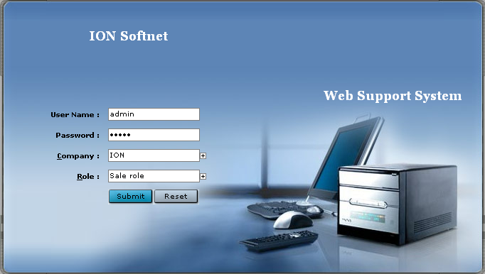

Chapter II

1. UDC and UDC Type

Purpose:

The values of the user defined code indicate the valid set of data that is specific to your business for a particular field. Each user defined code is either hard-coded or soft-coded. You can customize fields in your system by setting up user defined codes to meet the needs of your business environment. User defined codes are stored in tables that relate to a specific system and code type.

When you enter a value in a user defined code field the application checks the associated table to make sure it is a valid value. If no match is found, the program returns an error message “Type Mismatch”.

A) Adding Or Changing a User defined Code Type

A code type categorizes your user defined code values within a product code. When you add user defined code values, you are adding them to a specific code type; and therefore the code type must already exist before adding any values to it.

On the system Administration Menu

- Choose a code type to change or click Add to create a new type. Note (The code with Flag=1 means you
cannot change this UDC as this has been defined for a particular company).
- To add a new code type, in the last row of the grid, complete the following fields.
  - Product Code (can give any number to your UDC)
  - UDC Type (Should be max of max 5 characters)
  - Text (Description)
  - Company (company that UDC belongs to, or you can leave it blank which means it
belongs to all)
  - Flag (If flag=0 means you can update this UDC, if flag=1 means you cannot modify it)

- You can change or add multiple code types during the same session by pressing Enter.
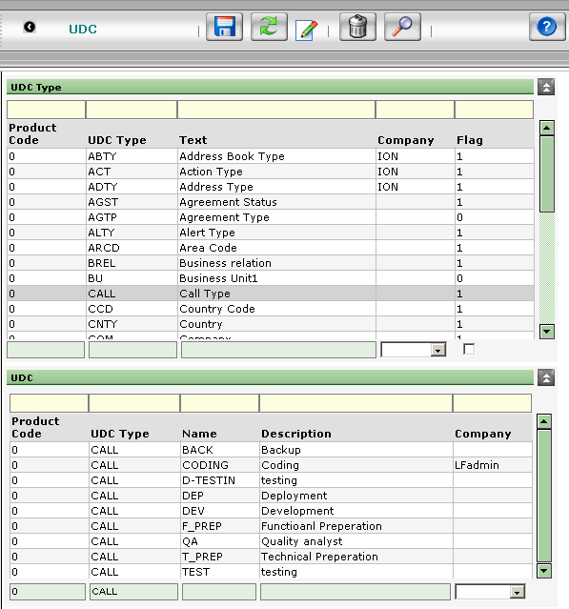

B) To Edit UDC Type and UDC
- Select any UDC and click on update button it will open a new window where you can edit the already
filled information. See the below screens shot

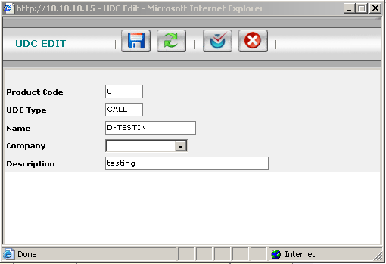

Product Code: Give any number
UDC Type: The type of UDC it is
Name: Abbreviation given for UDC

The above fields you cannot do the changes

Company: Name of the company that UDC belongs to
Description: Detail description of UDC

After doing the modification either click on SAVE button or OK

Chapter III

1. What is Template

Purpose:

The purpose of the Template Entry Screen is to create a predefined list of call and task that will help to populate the list of task under that particular call only if its type matches.

Template entry will come from Administration Center Menu. Below is the template view screen

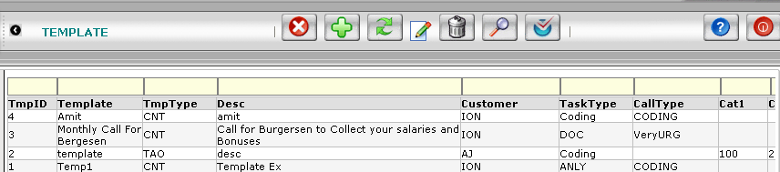

2. How to Create a Template

To create a new template click on add button. This button will take you to template detail screen where you can create your own template.

- Template Detail- To enter new template, this screen will have 3 drop down panels

  - Template Detail- Under this panel we will have following fields

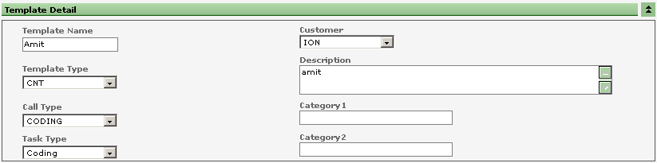
The data from these fields will be picked up from UDC

NOTE:- There will always be three type of Template

- Call and Task Template (CNT) If we select CNT type of Template then unless and until
user don’t fill call detail information he cant move to the next level or panel which is
Task Detail. For this template you have to create a call and assign task.
- Call Only Template (CAO)- User is only need to fill the call detail information
- Task Only Template (TAO)- User can straight away go to third level or panel i.e Task Detail panel to
- Create the task template after filling the information in template detail.

- Call Detail- This panel will be same what we have in our call detail screen

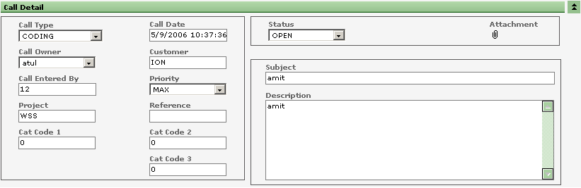

The following fields will be automatically filled as soon as we fill the template detail information
- Call Type
- Customer

Call Type: It has some predefined options in the UDC. Click on the Plus sign, 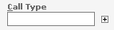 and a pop up window will open, we can select the call type from there.

Call Date: By default, it automatically picks up the current date.

Call Entered By: By default, it takes the current user name.

Priority: It has some predefined options in the UDC like-Normal, Urgent, Minimum, Maximum, High and Low.

Customer: It has some predefined options in the UDC. Click on the Plus sign and the pop up
window will open. We can select the option from there.

Call Owner: It has some predefined option from the UDC. On clicking the plus sign next to it, will open a pop up window and we can select the option from there.

Project: We can enter the name of the project. F.ex. Ion

Reference:

Agreement : It has some predefined options from the UDC. We can select the agreement
no/Type from the UDC.

Template Type: There are three types of template. They are predefined in the UDC. On clicking the plus sign, a pop up window will open and we can select the template type from there.

Template: It has some predefined options. Every template has some predefined tasks and actions (depending upon the type of template), so we can select the appropriate template depending upon the new call.

Cat Code 1, Cat Code2, Cat Code 3— It accepts only Numeric values.

Status: When we open a new call, then the status is OPEN, When we assign the call to the task owner, then the status is ASSIGNED.

Subject: Enter the Subject of the call.

Description: Give a brief description of the call.
Comment: We can add a special comment on the call. Click on the Comment Icon
and a pop up window will open. We can type the comment there and save it. After
adding the comment, the color of the Icon changes to Yellow, indicating that there
is a special comment attached here. If the comment is unread, then in the icon there will be three-four black lines, indicating that the comment is still unread and after reading the comment the black lines disappear.

Check out page 24-25 of this Doc for more on Comments

Attachments: We can attach files as attachments with this call. Click on the Attachments Icon , a pop up window will open, we can Browse the file and then attach it.

    - Task Detail- Under this panel we will have following fields

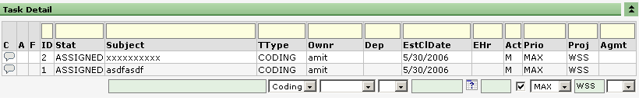

C: Comment Once the task is entered, the icon for the comment appears. On clicking the Icon, a window appears where we can enter the comment and save it.

A: Attachment If under this column, an Icon is displayed, then it indicates that this Task has a file attached with it. Click on Icon , and it will open a window with a list of all the attachment files for this Task. To View the files, Double click the file and it will open the file.
Form Form-If under this column, an Icon is displayed, then it indicates that this Task
has a form associated with it. Click on the Form Icon and it will open a window
with a list of all the forms associated with this task.

Subject Enter the Subject of the call

TType Task Type-Select TType from the drop down menu.. It has some predefined options.

Owner Select the Owner from the drop down menu. It displays a list all the users.

Dep It’s optional. Select the value from the drop down menu.

EstClDate Estimated Close Date-The close date of the calendar can be selected from the
calendar. Click on the calendar Icon to open the calendar.

EHr Estimated Hours-enter the estimated hours needed to complete the task.

Act If this check box is checked, then it becomes mandatory to enter the Actions for this
task. Unless and until, actions are filled for this task, task cannot be closed. Incase of mandatory, “M” is displayed, indicating that Actions are to be filled before closing the task.

Pri Priority-It indicates the priority of the task. It has some predefined options which can be selected from the drop down menu.

Proj Project-Name of the project can be entered. It’s optional.

Agmt Agreement-It’s optional. It has some pre-defined values which can be selected form the drop down menu.

Chapter IV

1. Address Book

Purpose:
The purpose of this screen is to give each person, customer, company or business location a unique identity in
the system.

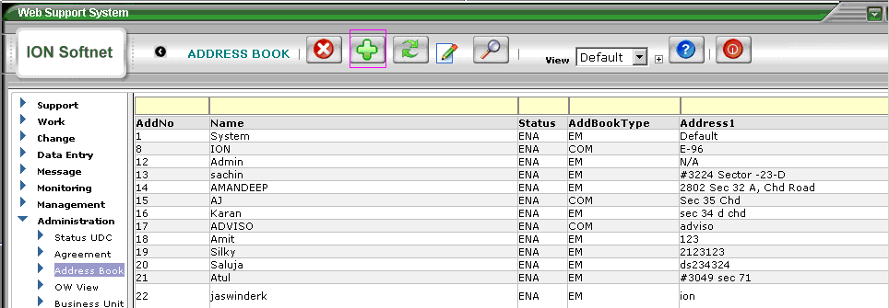

CLOSE BUTTON
OK BUTTON
SAVE BUTTON
RESET BUTTON
UPDATE/EDIT BUTTON
ADD BUTTON

Add No Address No.
Name Name of the New User or the Company.
Status It has some pre-defined types.
Disabled (DISA), Enabled (ENA), Hidden (HIDE), Visible (VSBL).
AddBook Type It has some pre-defined types.
Company (COM), Customer (CU), Employee (EMP), Manufacturer (MANF),
Supplier (SPL), Vendor (VND).
Address Physical Address of the User or the Company.

A) How to create new User/Company Address Book

To create a New Contact Details of a New User or a Company(Support Company/Client Company), Click on Add New Button. It will open up a New Form , where you can enter the Name, Address, City, Province, Postal Code, Country, Email, Phone No etc.

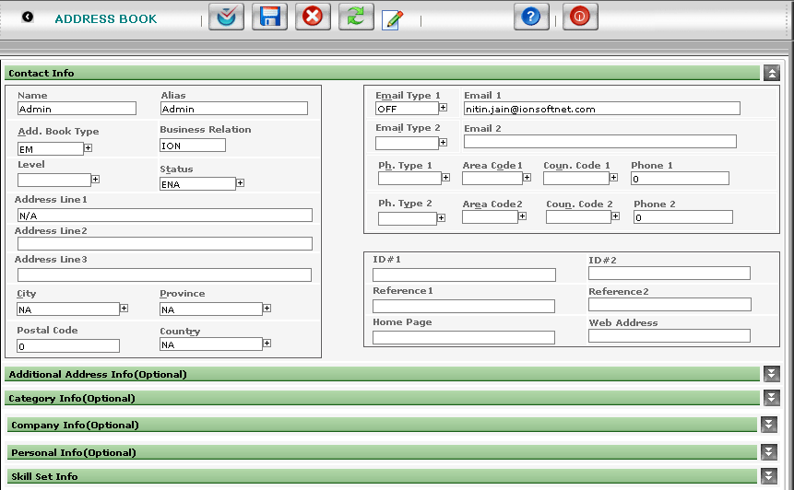

Starting from the First field i.e. Name, the description of all the fields are given below.

Name Enter the Name of the User. For Example, Peder.
Alias An Alias name can also be entered, but its not Mandatory.
AddBookType It has some Pre-Defined Options as shown in the picture below.
We can choose the option and then Double Click that particular option , then the option is entered automatically and the window also closes automatically.
To open this Menu, click on the small plus sign. 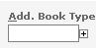 There is a Short Cut Key to open this menu. CTRL + SHIFT + A

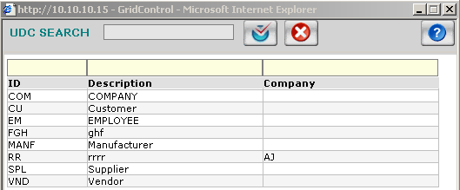

Business Relation
It also has some pre-defined options as shown in the picture below.
We can choose the option and then Double Click that particular option , then the option is entered automatically and the window also closes automatically.
To open this Menu, click on the small plus sign. 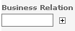 If AddBook Type is COM (Company), then these options are displayed in Business Relation.

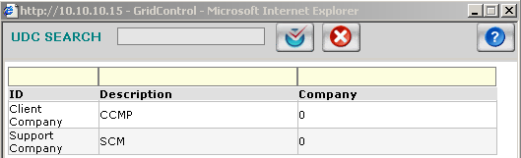

If AddBook Type is EM(Employee), then these options of the different companies are displayed.

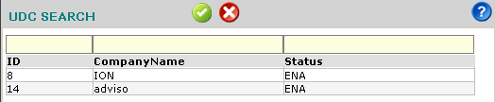

Status It has some Pre-Defined Options as shown in the picture below.
We can choose the option and then Double Click that particular option, then the option is entered automatically and the window also closes automatically. To open this Menu, click on the small plus sign 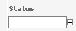There is a Short Cut Key to open this menu. CTRL + SHIFT + T

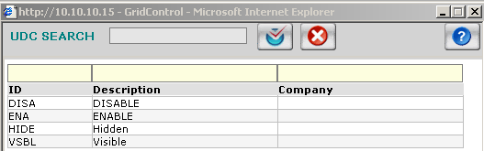

Address Line 1 , Address Line 2 , Address Line 3 –
Here we can Enter three different Address’s of the New User/Company

City It has some Pre-Defined Options as shown in the picture below. To open this Menu, click on the small plus sign 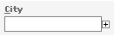 There is a Short Cut Key to open this menu. CTRL + SHIFT + C
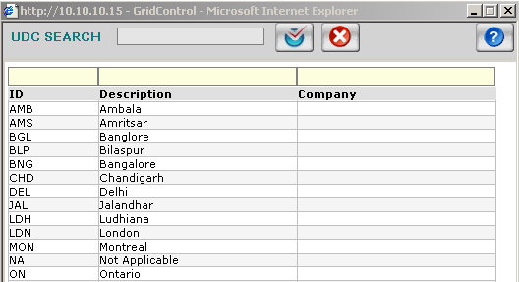

Province It has some Pre-Defined Options as shown in the picture below. To open this Menu, click on the small plus sign 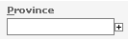 There is a Short Cut Key to open this menu. CTRL + SHIFT + P

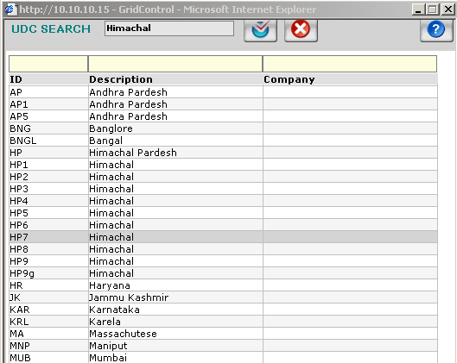

Postal Code Zip/Postal Code of the area should be entered here. It only accepts numeric’s.
Country It has some Pre-Defined Options as shown in the picture below. To open this Menu, click on the small plus sign. 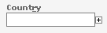 There is a Short Cut Key to open this menu. CTRL + SHIFT + R
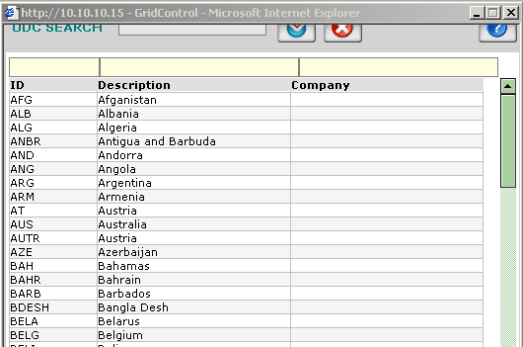

Email Type 1 It has some Pre-Defined Options as shown in the picture below. To open this Menu, click on the small plus sign 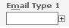 There is a Short Cut Key to open this menu. CTRL + SHIFT + M

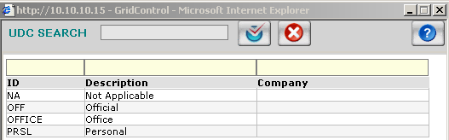

Email 1 Here we can enter the Email ID . For Example- peder@ionsoftnet.com
Similarly with Email Type 2 and Email 2 .

Ph Type 1 Here, we have to enter the Phone Type. It has some Pre-Defined Options as shown in the picture below.
To open this Menu, click on the small plus sign. 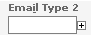 There is a Short Cut Key to open this menu. CTRL + SHIFT + I

Area Code 1 It has some Pre-Defined Options as shown in the picture below. To open this Menu, click on the small plus sign. 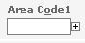 There is a Short Cut Key to open this menu. CTRL + SHIFT + O

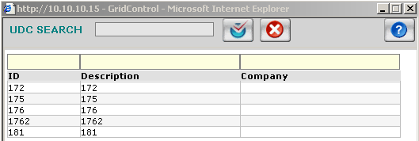

Coun Code 1 It has some Pre-Defined Options as shown in the picture below. To open this Menu, click on the small plus sign. 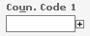There is a Short Cut Key to open this menu. CTRL + SHIFT + U
Similarly with Ph Type 2 , Area Code 2, Coun Code 2.

ID# 1, ID# 2, Reference 1, Reference 2, Home Page, Web Address fields are optional.

i) Contact Info

We can add more Information in the Additional address Info, Category Info, Personal Info and Skill set info Panels.
This information is not Mandatory.

ii) Additional Address Info

Additional information regarding the address can be added here. To add more addresses click on “Add More” button.
Name, Add Type, Add Lines, City, Province, Pst Code, Country, Status have been discussed before.

iii) Category Info

User can enter the various category codes. Its optional.

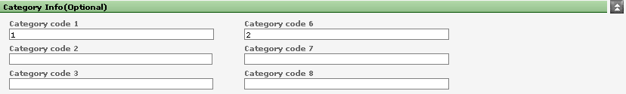\

iV) Company Info

This panel will be enabled only if the Address Book Type is “company” User can type in the details of the company.

Company Type: It has some predefined options. Click on the Plus sign and it will open the UDC options in a new window.

Opened Date : Enter .The date on which the company was opened. User can select the date from
the Calendar by clicking the calendar Icon.

Working Hrs From/To: Enter the Working hours of the company, so that some other user/client can check
the timings if he wants to contact .

No of Employees: Enter the total no. of Clients in the company.

V) Personal Info

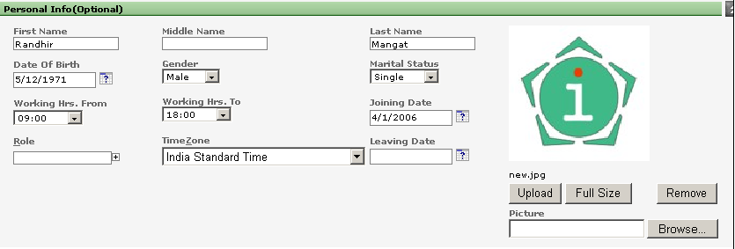

Under Personal Information, user can enter the personal details like First, Middle, Last Name.
Date Of Birth: It can be selected from the calendar by clicking the Calendar Icon.

Gender: It can be either Male/Female. These options are already predefined in the UDC.
Click the plus sign and the options will open in anew window.

Marital Status: It has some predefined options in the UDC.

Working Hrs: User can specify the Working hrs.

Joining Date: User can select the joining date from the Calendar

Role: It has some predefined options in the UDC.

Time Zone: User can specify the Time Zone from the drop down box.

Picture: User can add a picture also.

Vi) Skill Set Info

User can add the various skill set details.
Skill Type and Skill has some predefined options. User can select them from the UDC.
Comment: Its optional.
After entering all the necessary and required information in the Form, click on the SAVE button to save the new User/Company detail.
Once the Record is saved, you will get a Confirmation Message at the top of the Window.

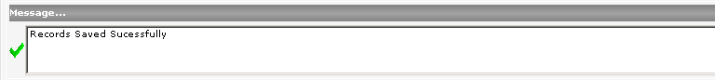

Chapter V

1. How to create User Profile

Purpose:
The purpose of this function is to set the correct security on the user. The user information is in the
Address Book. We have to create a User Profile with a Unique User Name and Password.

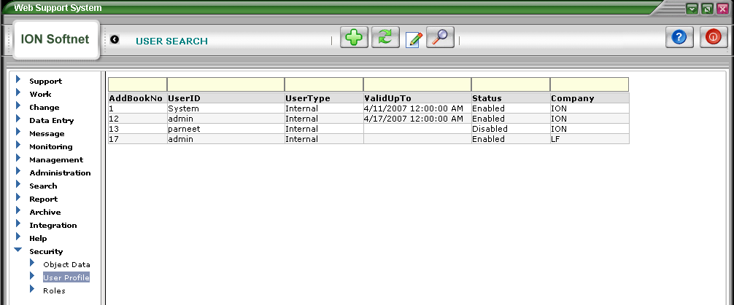

The above screen displays the List of all the existing Users with description about the AddBookNo, UserID, UserType,ValidUpto, Status and Company. To create a new User Profile for a New User, Click on Add New Icon. This will open up a new screen.

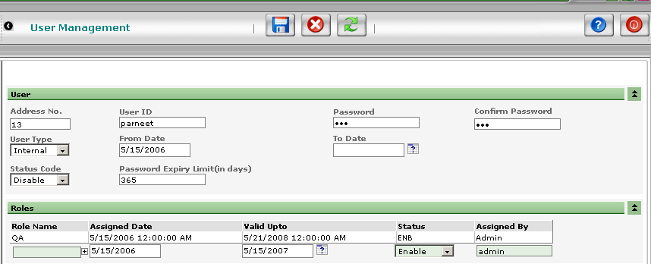

Enter the User ID for the New User, then enter the Password and Confirm the password again.
Address No Once entry of the New User has been made in the Address Book, then it auto creates an Address No. So, it has a pre-defined list, and we can select the new user option from the list. To open the list/menu, click on 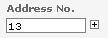

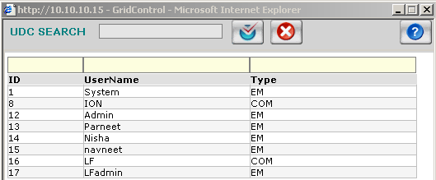

User Type It has two pre-defined options, Internal or External..
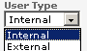We can select the appropriate option from the Drop Down Menu

From Date It is the Date on which the User profile is created. By Default it takes the Current Date automatically.
To Date It is the Date, till when the User Profile will remain Active. We can select the Date from the Calendar.
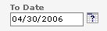 We can click on the Calendar Icon to open the Calendar.

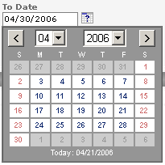 Now , we can select the Expiry Date of the User Account.

Status Status has two pre-defined options—Enabled and Disabled.

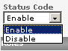 We can select the appropriate option from the drop down menu.
If ENABLED is selected, then the user will be able to Login. and if DISABLED is selected, then the user will not be able to Login.

Password Expiry Limit --- It is automatically 356 days. We cannot change this field.

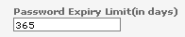

Roles Select the type of role that you want to assign to the new user. For example, Sales Role, HR Role etc.

Role Name- It has some pre-defined options . To see the options window, click on the small plus sign.

Assigned Date It automatically sets the current date.

Valid Upto From the calendar, we can select the valid upto date. To open the calendar, click on the calendar Icon.
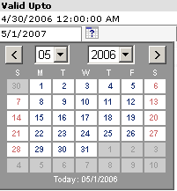
Status Status has two pre-defined options—enabled and Disabled.

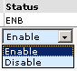 We can select the appropriate option from the drop down menu.
If ENEBLED is selected, then the particular Role will get enabled and the user will be able to Login with that Role. And if, DISABLED is selected, then the User will not be able to Login with that Role.
This is used when a User has been provided lot of Roles.

Assigned By By default, it picks the name of the user who is creating the New role.

Chapter VI

1. How to provide security to a Role

Purpose:
The Purpose of this screen is to give and take away the access of different modules, screens, fields and
buttons to different user/role of different companies.

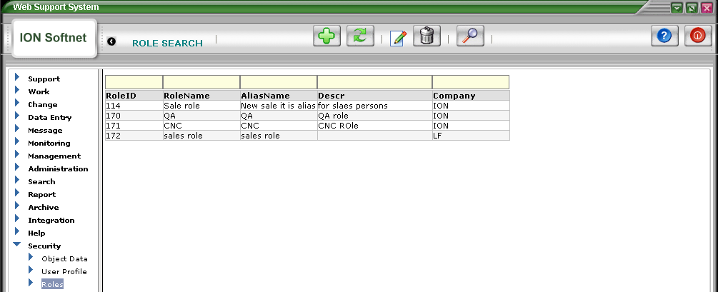

This screen displays the list of all the Role Names with their respective unique ID’s. After we have entered the information in the Address Book and created the User Profile, next task is to assign the Role Security. In this we can enable and disable or hide, the options that we don’t want the new user to see and change. This is for the security purposes.

When we have several user’s, we don’t want all the users to have all the access rights, so from the Role Security, we can give the selected rights to the users.

For Example, Admin has all the rights to View and make changes anywhere. Where as, we don’t want all the
users to have all rights. So we can restrict the rights depending upon what kind of Role is assigned to the user.

From Role, we can select the access level at the Menu, screen and controls level.

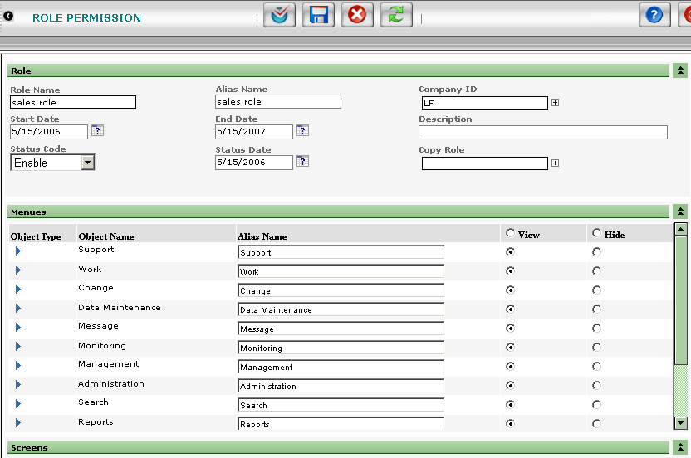

A) At Menu Level
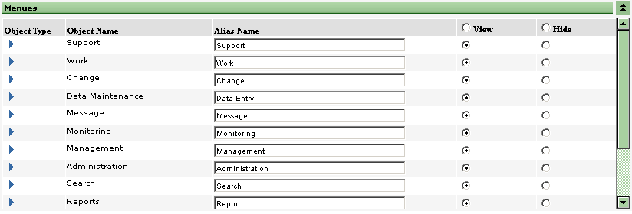

From here, we can VIEW or HIDE, the screens that we don’t want the user to access. For Example, if we Hide the Support and Change Menu’s, then under that particular user’s Login, he wont see these menu’s.
So he won’t be able to view data and information under these Menu’s and further, he wont be able to make any changes.

Screen Level

Then we can select a particular Menu, and further we can apply security at the Screen Level.
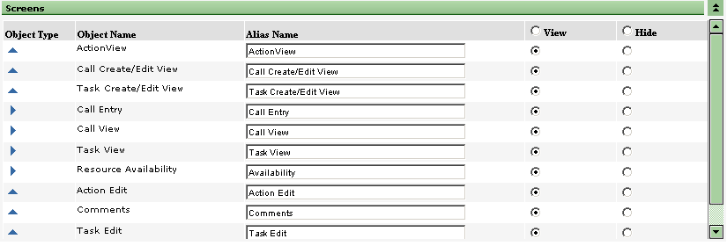

From here, we can again, View and Hide, the particular screens, that we don’t want the user to view and make changes. If we select View, then user will be able to view all the information and data under that particular screen. He can navigate through the records.

If we select Hide, then he won’t be able to view the screen. So he can’t even see the information and data in that particular screen.

Further, we can also hide, Disable and Enable the buttons on these screens. Select a screen, and then in the Controls we can select the rights that we want to give.

D) Control Level

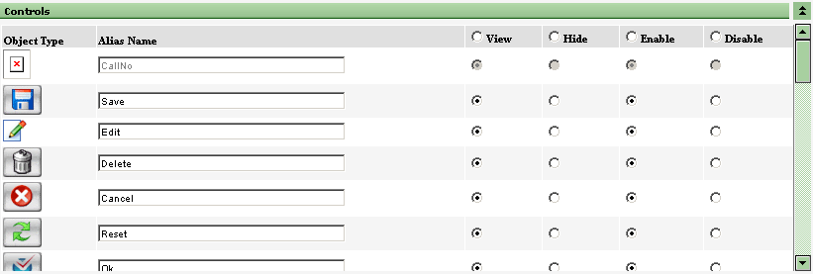

From here, we can Hide, View, Disable and enable the buttons according to the access level that we want to provide to the user.

If we select Hide, user won’t be able to see that button. If we select Disabled, the button will be disabled, i.e. no action will happen on clicking the button.

For Example, for Delete button, if we make it View and Disabled then, user will be able to View the button the screen but if he clicks on it nothing with happens as its disabled.

So, this is for the Security purpose, the user will not be able to Delete any records.

Chapter VII

1. Call Entry

Purpose:

All things in WSS start with a CALL. A CALL can be an error, a question, a project task etc. A CALL is the log of
something needed to be executed.

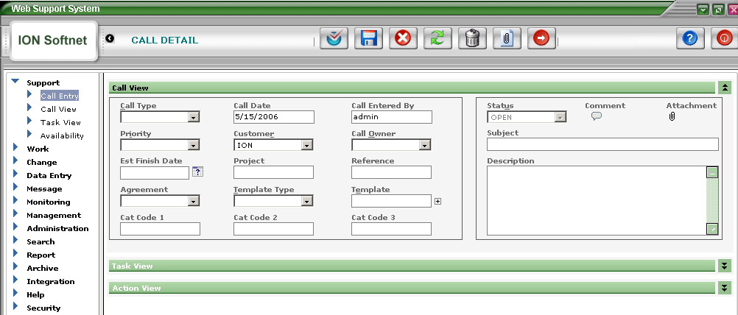

Call Entry is done on this screen. After entering all the information, we can save the call, then we can fill the corresponding tasks and actions for this call.

Call Type: It has some predefined options in the UDC. Click on the Plus sign, and a pop up window will open, we can select the call type from there.

Call Date: By default, it automatically picks up the current date.

Call Entered By: By default, it takes the current user name.

Priority: It has some predefined options in the UDC like-Normal, Urgent, Minimum,
maximum, high or Low.

Customer: It has some predefined options in the UDC. Click on the Plus sign and the pop up window will open. We can select the option from there.

Call Owner: It has some predefined option from the UDC. On clicking the plus sign next to it, will open a pop up window and we can select the option from there.

Est Finish Date: Here, we can specify the finish date of the call. On clicking the calendar icon, a
calendar will open, and then we can select the date from there.

Project: We can enter the name of the project. F.ex. Ion

Refrence:
Agreement : It has some predefined options from the UDC. We can select the agreement no/Type from the UDC.

Template Type: There are three types of template. They are predefined in the UDC. On clicking the
plus sign, a pop up window will open and we can select the template type from
there.

Template: It has some predefined options. Every template has some predefined tasks and actions (depending upon the type of template), so we can select the appropriate template depending upon the new call.

Cat Code 1, Cat Code2, Cat Code 3— It accepts only Numeric values.

Status: When we open a new call, then the status is OPEN,
When we assign the call to the task owner, then the status is ASSIGNED.
When, the task owner enters the respective tasks and actions on the call,
then status becomes PROGRESS.
And finally, when all the task are closed, then status is CLOSED.
We can also re-open the call, then status will become RE-OPEN.

 | STATUS
Open a new call | OPEN
Assign Task | ASSIGNED
Enter Actions | PROGRESS

Subject: Enter the Subject of the call.

Description: Give a brief description of the call.
Comment: We can add a special comment on the call. Click on the Comment Icon and a pop up window will open. We can type the comment there and save it. After adding the comment, the color of the Icon changes to Yellow, indicating that there is a special comment attached here. If the comment is unread, then in the icon , there will be three-four black lines, indicating that the comment is still unread and after reading the comment the black lines disappear.
Check out page 24-25 of this Doc for more on Comments

Attachments: We can attach files as attachments with this call. Click on the Attachments Icon , a pop up window will open, we can Browse the file and then attach it.

Buttons

OK
SAVE After, entering the new call, we can click on the SAVE button to save the new call.
CANCEL If we want to cancel the changes made.
REFRESH It will refresh the page, all changes that were not saved will be deleted.
DELETE It will delete the records.
ATTACHMENT With this button, we can attach files with the call.
CALL We can forward the call to the other person, using this button.
FORWARD

A) How to Create a New Call
Enter the new call data, attach any files if needed or comments, then click on the SAVE button to save the new call in the records. The status of the new will be OPEN, once the task is assigned, then the status will automatically become ASSIGNED. Further, on entering the Actions, the status of the call will become PROGRESS.

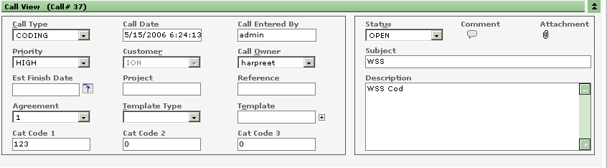

Once the call is saved, we can fill the Tasks on the same screen in the Task Panel. And after filling the tasks, we can also fill the Actions in the Action Panel on the same screen.

See the Screen Shot below.

B) How to Assign a New Task and Action

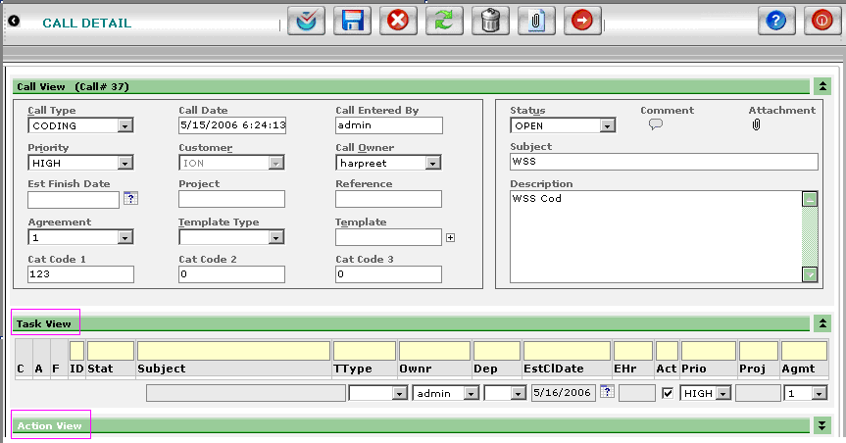

Assigning a Task

C: Comment Once the task is entered, the icon for the comment appears. On clicking the Icon, a window appears where we can enter the comment and save it.

A: Attachment If under this column, an Icon is displayed, then it indicates that this Task has a file attached with it. Click on Icon , and it will open a window with a list of all the attachment files for this Task. To View the files, Double click the file and it will open the file.
F Form-If under this column, an Icon is displayed, then it indicates that this Task
has a form associated with it. Click on the Form Icon and it will open a window
with a list of all the forms associated with this task.

Subject Enter the Subject of the call

TType Task Type-Select TType from the drop down menu.. It has some predefined options.

Ownr Select the Owner from the drop down menu. It displays a list all the users.

Dep It’s optional. Select the value from the drop down menu.

EstClDate Estimated Close Date-The close date of the calendar can be selected from the
calendar. Click on the calendar Icon to open the calendar.

EHr Estimated Hours-enter the estimated hours needed to complete the task.

Act If this check box is checked, then it becomes mandatory to enter the Actions for this
task. Unless and until, actions are filled for this task, task cannot be closed. Incase of mandatory, “M” is displayed, indicating that Actions are to be filled before closing the task.

Pri Priority-It indicates the priority of the task. It has some predefined options which can be selected from the drop down menu.

Proj Project-Name of the project can be entered. It’s optional.

Agmt Agreement-It’s optional. It has some pre-defined values which can be selected form the drop down menu.

Filling action to an assigned task

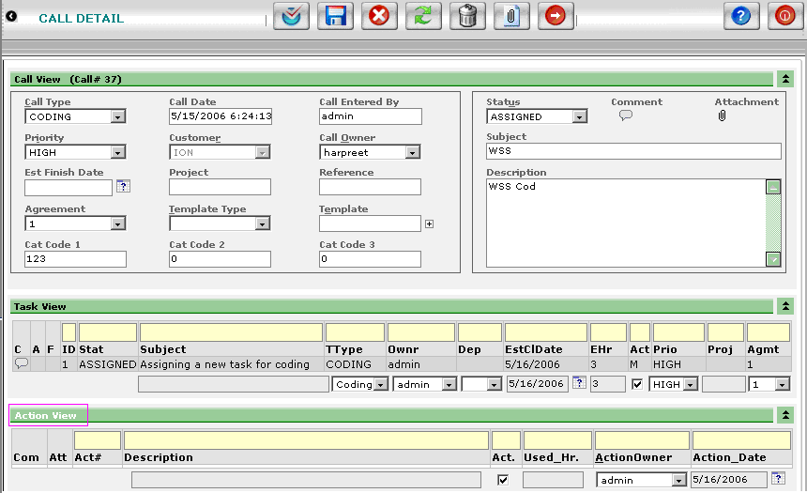

C: Comment Once the task is entered, the icon for the comment appears. On clicking the Icon, a window appears where we can enter the comment and save it.

A: Attachment If under this column, an Icon is displayed, then it indicates that this Task has a file attached with it. Click on Icon , and it will open a window with a list of all the attachment files for this Task. To View the files, Double click the file and it will open the file.

Description Enter the description for the action done for that task

Act If this check box is checked, then it becomes mandatory to enter the Actions for this
task. Unless and until, actions are filled for this task, task cannot be closed. Incase of mandatory, “M” is displayed, indicating that Actions are to be filled before closing the task.

UsedHr Here you can give the actual hrs you have put into completing that particular task

ActOwnr Select the ActOwner from the drop down menu. It displays a list all the users.

ActDate Select the ActDate the date when you did that action. NOTE you can select the back date.

C) How to View Call once saved

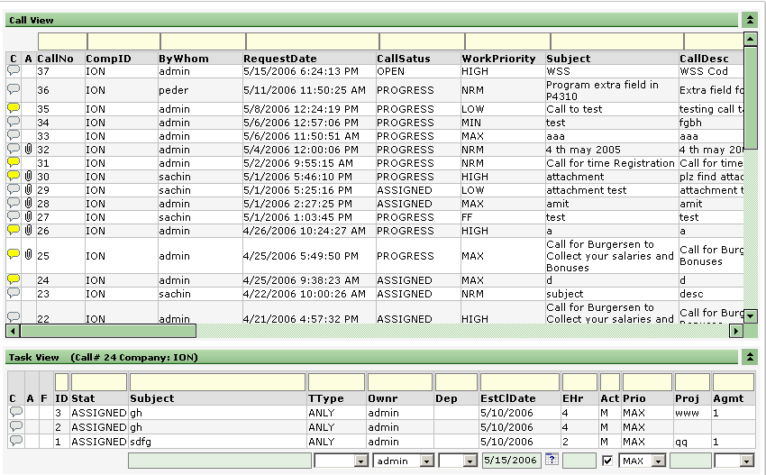

Under this screen, a list of all the calls is displayed with their call no, Request Date, Call Status, Priority, description details. We can also fill the tasks for the respective calls. To enter tasks at the Task View Panel, highlight the call, then the Task view panel will be enabled, and we can enter the tasks there and then we can save it. We can also attach comments to the task and can also attach files.

If we double Click any call, it will open the Call Details/Call Edit window. We can make respective changes and then save it.

SEARCH
VIEWS—discussed in detail later

SAVE After, entering the new call, we can click on the SAVE button to save the new call.

ADD NEW It opens the Call Details window, we can add new call .

REFRESH It will refresh the page, all changes that were not saved will be deleted.

EDIT It will open the call edit screen and we can edit the call and its details.

SHOW/ HIDE If we click on this button once, it will SHOW call the calls and if we click it second time, it hides all the closed calls and only shows the calls in progress and assigned status.
SEARCH Type any keyword in the search boxes and then click on this button, it will only display the matching results.
ATTACHMENT With this button, we can attach files with the call or task.

Under call View :
- We can Edit the details of the call. For this, Select the call, and then click on the Edit button or simply double click the call. It will open the call edit screen and there we can make the respective changes. After all the changes have been made, click on save button, to save all the changes.
- Enter the tasks for the calls. For this, select the call, and then in the Task View Panel, the details of the Task will be listed. We can add more tasks to the call. Click save button to save the changes.

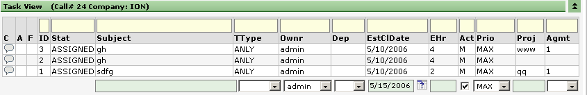

C Comment-once the task is entered, the icon for the comment appears. On clicking the Icon, a window appears where we can enter the comment and save it.
A Attachment- If under this column, an Icon is displayed, then it indicates that this Task has a file attached with it. Click on Icon , and it will open a window with a list of all the attachment files for this Task. To View the files, Double click the file and it will open the file.
F Form-If under this column, an Icon is displayed, then it indicates that this Task has a form associated with it. Click on the Form Icon and it will open a window with a list of all the forms associated with this task.

Subject Enter the Subject of the call

TType Task Type-Select TType from the drop down menu.. It has some predefined options.

Owner Select the Owner from the drop down menu. It displays a list all the users.

Dep It’s optional. Select the value from the drop down menu.

EstClDate Estimated Close Date-The close date of the calendar can be selected from the calendar. Click on the calendar Icon to open the calendar.

EHr estimated Hours-enter the estimated hours needed to complete the task.

Act If this check box is checked, then it becomes mandatory to enter the Actions for this task. Unless and until, actions are filled for this task, task cannot be closed.
Incase of mandatory, “M” is displayed, indicating that Actions are to be filled before closing the task.

Pri Priority- It indicates the priority of the task. It has some predefined options which can be selected from the drop down menu.

Proj Project-Name of the project can be entered. It’s optional.

Agmt Agreement-It’s optional. It has some pre-defined values which can be selected form the drop down menu.

D) How to View Task once saved

This screen displays a list of all the Tasks for all the calls, with their comments and attachment files and Forms.

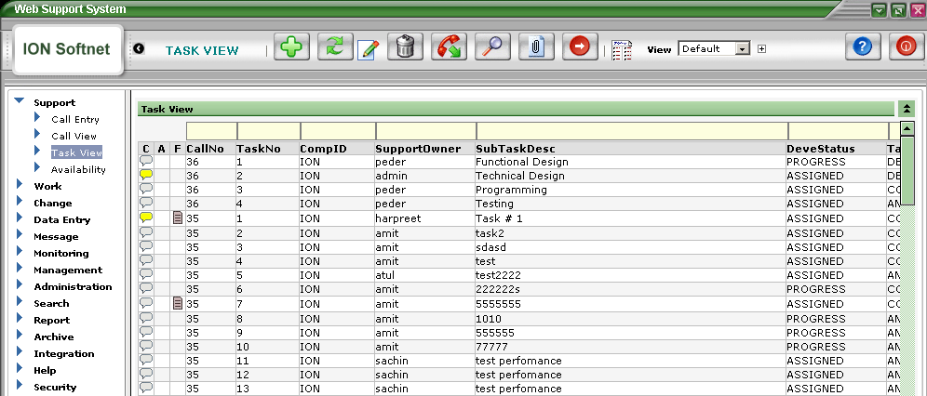

This indicates that there is no comment attached with the Call and Task.

This indicates that a special comment is attached to this Call/Task, but it has already been viewed.
This indicates that there is a special comment attached to this call and task and it has yet not been viewed by anyone. One we click on this Icon, it opens a window, and then on closing the window i.e. after viewing the comment the Icon changes to.

We can click on Attachment Icon, to open and view the attachment files associated with a particular call and task. Further, as discussed before, this Icon, indicates that a Form is associated with the call and task. On clicking this icon, it will open the window that will display all the forms.
Moreover, we can SEARCH for specific results from the search boxes. We can type in the keyword and then hit Enter Key or the Search Button and it will display the results.

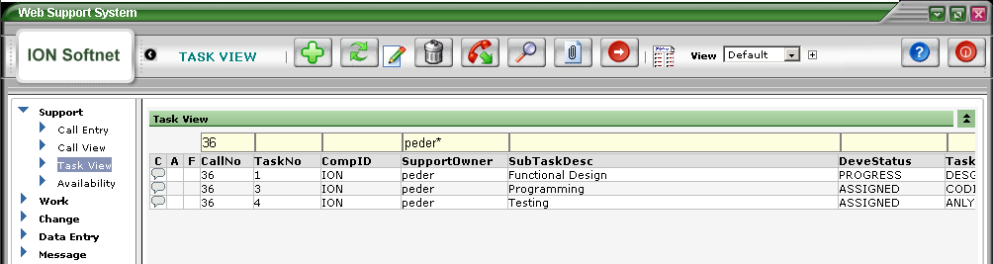

As shown in the Screen Shot above, Call No=36, and Support Owner=p*(i.e. it should start from “p”)
Now, it will display all the record where call no is “36” and the Task Owners name starts from “p”.
Search option makes it easy for the user to fetch specific records with minimum time.

Chapter VIII

1. Work

In this Module, we can fill the Actions for the Tasks. Under Work View and to Do List, we can enter the Action
details.

A) How to view the tasks and actions

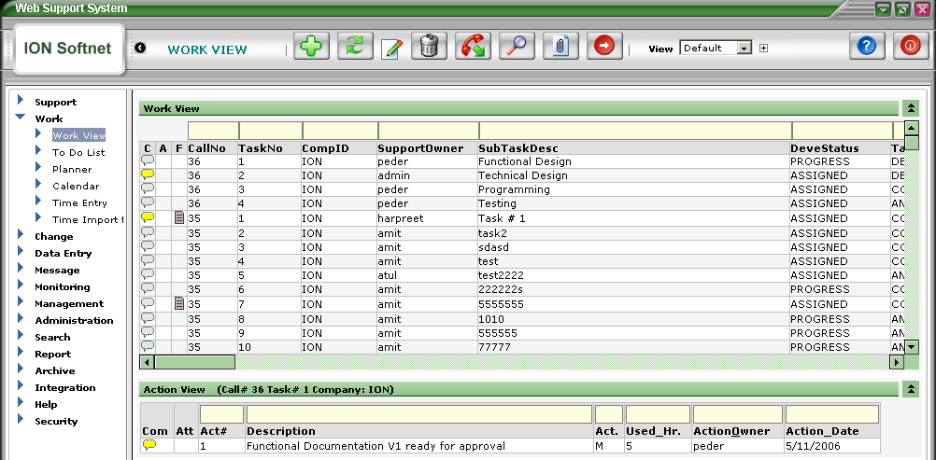

Explanation

BUTTONS

ADD NEW It opens the Call Details window, we can add new call .
REFRESH It will refresh the page, all changes that were not saved will be deleted.
EDIT It will open the call edit screen and we can edit the call and its details.
DELETE It will delete the records

SHOW/ HIDE If we click on this button once, it will SHOW call the calls and if we click it second time, it hides all the closed calls and only shows the calls in progress and assigned status.
SEARCH Type any keyword in the search boxes and then click on this button, it will only display the matching results.
ATTACHMENT With this button, we can attach files with the call or task.

TASK FORWARD We can forward the Task to the some other person, using this button.

2. To Do List

A) How to fill the actions to the tasks assigned to me?

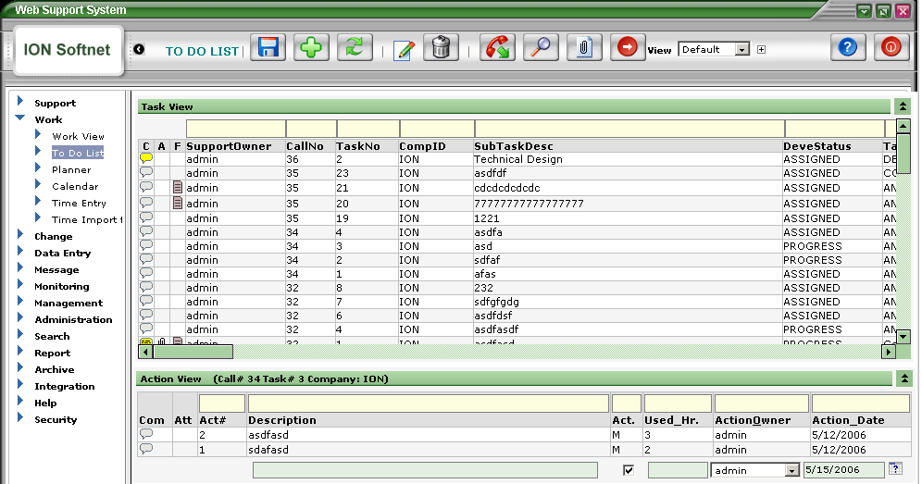

This screen displays all the Tasks along with their Status, Comments, Open date, Close date, attachments and forms. If we select a Task, then it also displays the Actions for that task in the Action View Panel below. We can see the Actions already filled and can also fill more Actions.
This screen displays the Tasks that a user has to complete along with the Target Estimated close dates.
User can directly enter the Action details and save the Actions.

This indicates that there is no comment attached with the Call and Task.

This indicates that a special comment is attached to this Call/Task, but it has already been viewed.
This indicates that there is a special comment attached to this call and task and it has yet not been viewed by anyone. One we click on this Icon, it opens a window, and then on closing the window i.e. after viewing the comment the Icon changes to.

We can click on Attachment Icon, to open and view the attachment files associated with a particular call and task. Further, as discussed before, this Icon, indicates that a Form is associated with the call and task. On clicking this icon, it will open the window that will display all the forms.
Moreover, we can SEARCH for specific results from the search boxes. We can type in the keyword and then hit Enter Key or the Search Button and it will display the results.

Views discussed later.

BUTTONS

SAVE After, entering the new call, we can click on the SAVE button to save the new call.

ADD NEW It opens the Call Details window, we can add new call.

REFRESH It will refresh the page, all changes that were not saved will be deleted.

EDIT It will open the call edit screen and we can edit the call and its details.

DELETE It will delete the records

SHOW/ HIDE If we click on this button once, it will SHOW call the calls and if we click it second time, it hides all the closed calls and only shows the calls in progress and assigned status.
SEARCH Type any keyword in the search boxes and then click on this button, it will only display the matching results.
ATTACHMENT With this button, we can attach files with the call or task.

TASK FORWARD We can forward the Task to the some other person, using this button.

Chapter IX

1. Change Management

Introduction

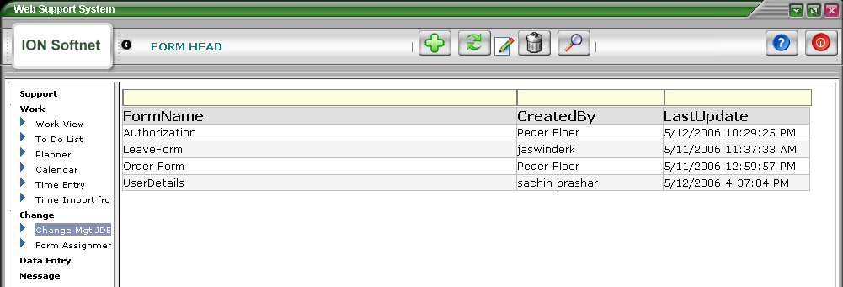

The Form Head Screen displays the list of all the forms. On double clicking the Form, it opens the Form Entry screen. We can edit the form details and add more details and save the changes.

The screen shot below shows the Form Entry Screen. It has five Panels: Request Information, Project Details, Technical Worksheet, Tab 4 and Tab 5.

Each Panel has text boxes, where we can add information that we wan to display. It has DateTime and MultiLine text boxes.

Various Panels in the Form Entry Screen:
- Request Information
- Project Details
- Technical Worksheet
- Tab 4
- Tab 5

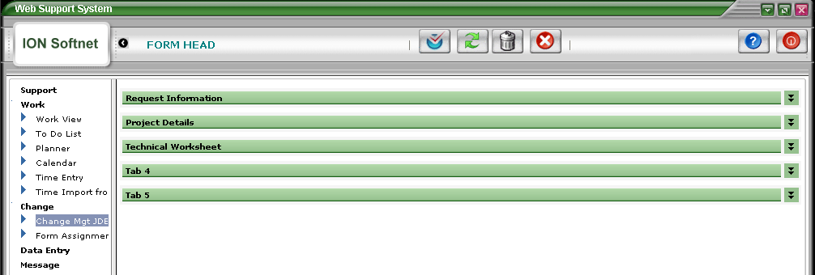

A) To create a New Form:

To create a New Form, click on the New Button , it will open the FORM ENTRY SCREEN, as shown in the next screen shot.
Enter the Name of the Form and rest of the details in the different Panels and then click OK button.

1. Request Information Panel

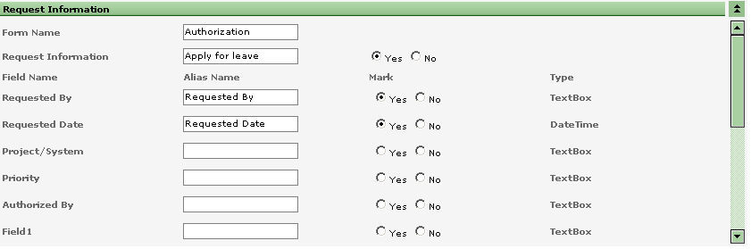

Form Name: Give the name of the Form. For Example, Leave Form, Human Resource
Fill the information in the fields and .then select the “Yes” Radio Button to display the field onto the Form. If we select “NO”, the filed will not be displayed on the Form.
If a Date is to be displayed, select the DateTime Field. For Example, Date Of Birth.

Other Panel are also same. Tab 4 and Tab 5 are provided if incase, more information is to be displayed in the Form.

B) To Edit a Form:

Double Click the Form, that you want ot Edit, it will open the Form Details Screen, make necessary changes to the Form, and after Editing the Form, click on the OK button . It will save the changes made to the existing Form.
To Refresh the Form, click on the REFRESH button .
To Delete a Record, click on the DELETE button .
And lastly, to cancel all the changes, click on the CENCEL button . All the information, that was not saved will be lost.

2. Form Assignment

A) How to view the activated form for any company

Once the Forms have been created, we can simply select the Company Name from the drop down menu and it will display a list of all the Active Forms for selected company. User can Double Click the Form and Preview the Forms, but cannot make any changes to the Form. we can assign the Forms. For this, we have to select the Company Name
Then, click on the SEARCH button , to list down all the activated Forms.

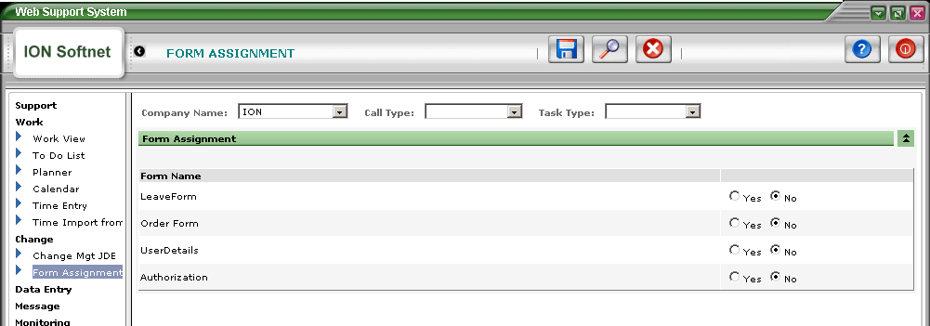

B) How to Attach form to a call/task

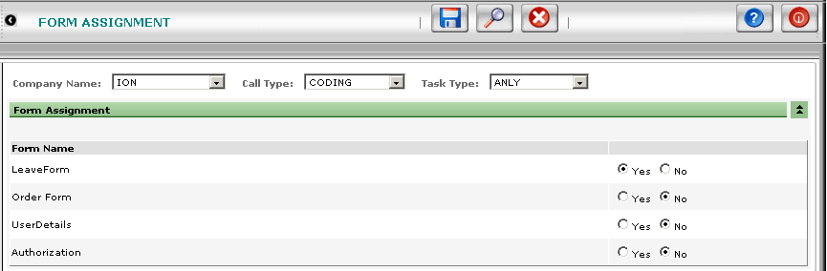

Now select call type and task type and then Select “Yes” if you want any of the Form to be attached to the corresponding Call and Task Type, Else select “No”.
After selecting the Form Click on the Save Button to save the changes.

After saving, a message will appear on the top of the Screen, that records saved successfully.

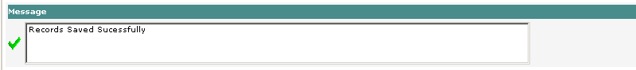

This indicates that the changes have been saved. For Example, if there is a call with Call Type “CODING” and Task Type “

If a Call/Task has a form Icon, , it indicates that there is a Form associated with this particular Call/Task Type.
We can Double Click on the Form Icon, and it will open a New window with a list of forms.
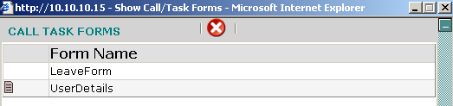

The second Form has another form icon, which indicates that this form has some data in it.
User can double click any form and then form will open Form Entry Details Screen as shown in the Screen Shot below.

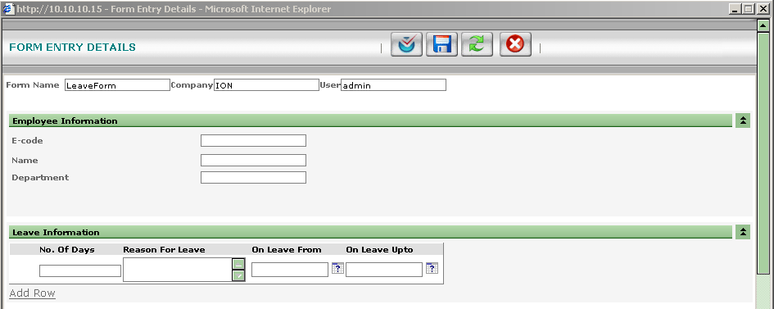

Enter the data in the form and click Save button .In the Second Panel, user can add as many rows by clicking “Add Row”.
To Refresh the page, hit REFRESH button and to cancel all the changes, hit CANCEL button .

Chapter X

1. User Overwrite View

Purpose:

This function will give you a very flexible choice when you are selecting the display of a screen or the selection in a batch report.

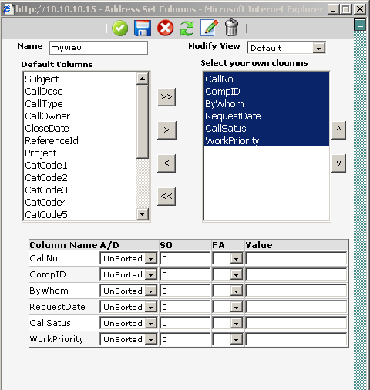

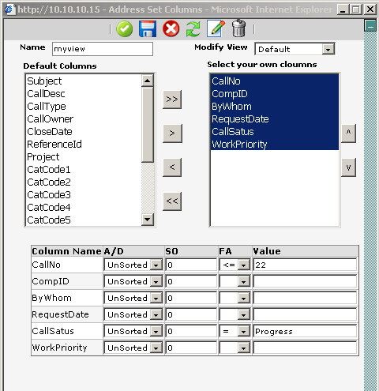

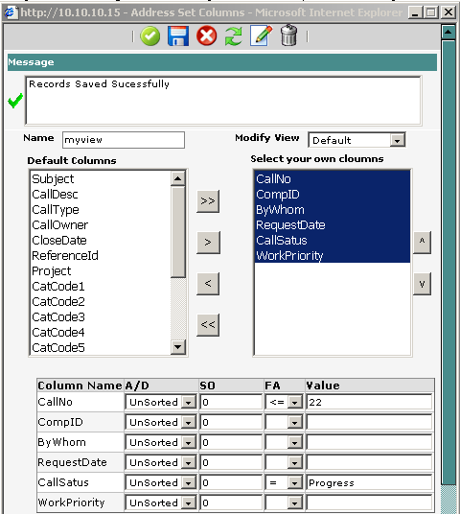

Column in picture named A/D stands for Ascending and Descending which will state in what order the records in that column will be displayed.

SO stands for Sorting. Than is how the priority off the sorting will be. Unless anything is stated it is gone be in the order they are selected. 1 in the field will make that specific column higher ranked in the sorting. The 2 will follow etc. Then it sorts the once without numbers as they are set in the selection.

FA stands for Factor. This is for limiting the selection of records belonging to that field. A Factor could be such as Equal (=), Less Than (<), More Than (>) etc… When you choose a factor you also have to choose a value

